NOTICE
Subject: Commencement of Classes for Nov-Dec 2025 Session.
All students of 1st, 3rd and 5th Semesters are hereby informed that their regular classwork will commence on 01-09-2025. It is mandatory for all students to be punctual and adhere to the class schedule. A minimum attendance of 75% is required for students to be eligible for the final examinations. It is reiterated that wearing the college uniform is compulsory.

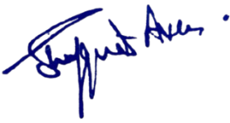

No: No: KGP/Estt/2025/938
DaaDated:30-08-2025

Principal
Kashmir Government Polytechnic College
Srinagar

Copy to the:
- All concerned for information and compliance.
2. Office File.

